1) We have installed Qt and have complete access to it.

2) **Team Members** Kushay Kejriwal (kushayk@gmail.com)  
 Ross Perry (rrperry99@gmail.com)   
 Vipul Kamani (vkamani@g.ucla.edu)

**PIC GOLF (temporary)**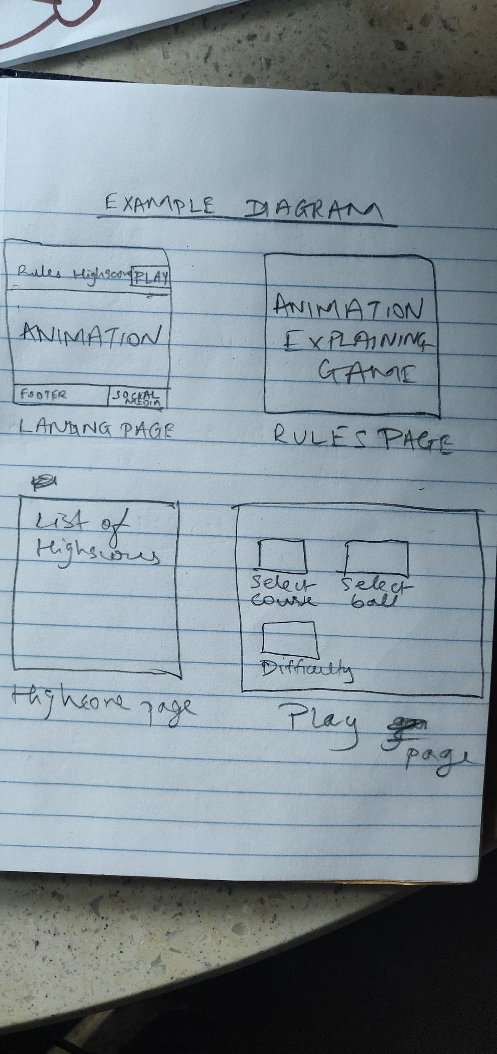

Structure and Navigation:

We are creating a minigolf game. The landing page will display an example animation of the game, and contain a navigation panel that allows users to toggle between the pages. The Rules page in turn, will have animations that explain the process of the game (could be interactive). On the other hand, the Highscores page will simply display past scores. Lastly, the play button will redirect users to a page that allows them to select certain game options before proceeding to the game window.

Gameplay:

The game would consist of a screen which displays the shape of the course and a ball which would travel in a straight line when hit. As shown in the diagram, the goal of the game would be to place objects to alter the path of the ball in order to make it travel toward the hole. The player would be given access to a certain number of reflective obstacles, essentially making this a puzzle game. The player, after having placed the obstacles, would press a button to launch the ball, and the game would give feedback to tell them whether or not the ball went into the hole. Possibly, we could code a small physics element into the game to show the path of the ball even if the obstacles are placed incorrectly. 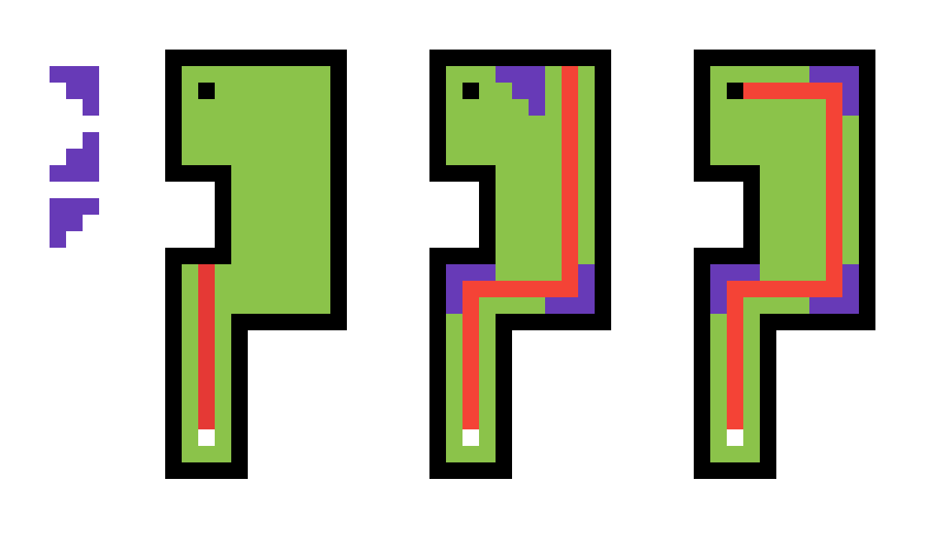

Schedule:

|  |  |  |  |
| --- | --- | --- | --- |
| Week | Plan | Week | Plan |
| 1,2 | Plan | 7,8 | Create assets, expand as time allows |
| 3,4 | Code Mechanics of game | 9,10 | Present |
| 5,6 | Create interface and interactive elements |  |  |